**Tutorial 10**

1. Before a program can read data from a file, which of the following must be true?

A. The file must exist and data to be read from it must have been previously stored in it.

B. There must be a #include <fstream> directive in the program.

C. The program must define a file stream object to associate with the file.

D. The file must be opened.

E. All the above statements must be true.

1. What error could occur if you forget to close an output file?
2. List THREE (3) advantages of using files for input and output as opposed to the standard input and output you’ve used so far in this course.
3. Perform the following tasks:
4. Prompt the user to enter his name and age.
5. Open a text file called myself.dat for output. Use file stream variable **myfile**.
6. Write his name and age into the text file myself.dat. The sample format of the file is as below:

Name: James | Age: 18

1. Close the text file.
2. Given a text file named **result.dat** as shown below, that stores the grades and marks obtained by a student in a test for various subjects.

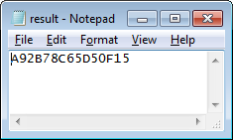

result.dat

Use C++ statements to perform the following tasks:

1. Declare the file stream variable **MarkFile** and use it to open the above text file result.dat for input
2. Check if the result.dat file is opened successfully, if not, display the error message ‘File opening error” and exit the program.
3. Read the data from the result.dat file and display the output as shown in the following screen.

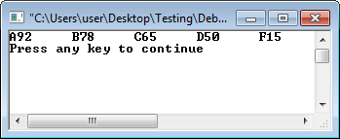

result.dat

1. Close the result.datfile.
2. Write C++ program to read the following student ID and test scores from a file named students.dat

Input file (students.dat):

08WAD123456 70 88 59 49 56

08WAD123457 56 44 90 45 89

: :

: :

:

Calculate the average test score and print the output shown below to a file named compilation.dat*:*

Student ID: 08WAD123456

Test scores: 70 88 59 49 56

Average test score: 64.4

Student ID: 08WAD123457

Test scores: 56 44 90 45 89

Average test score: 64.8